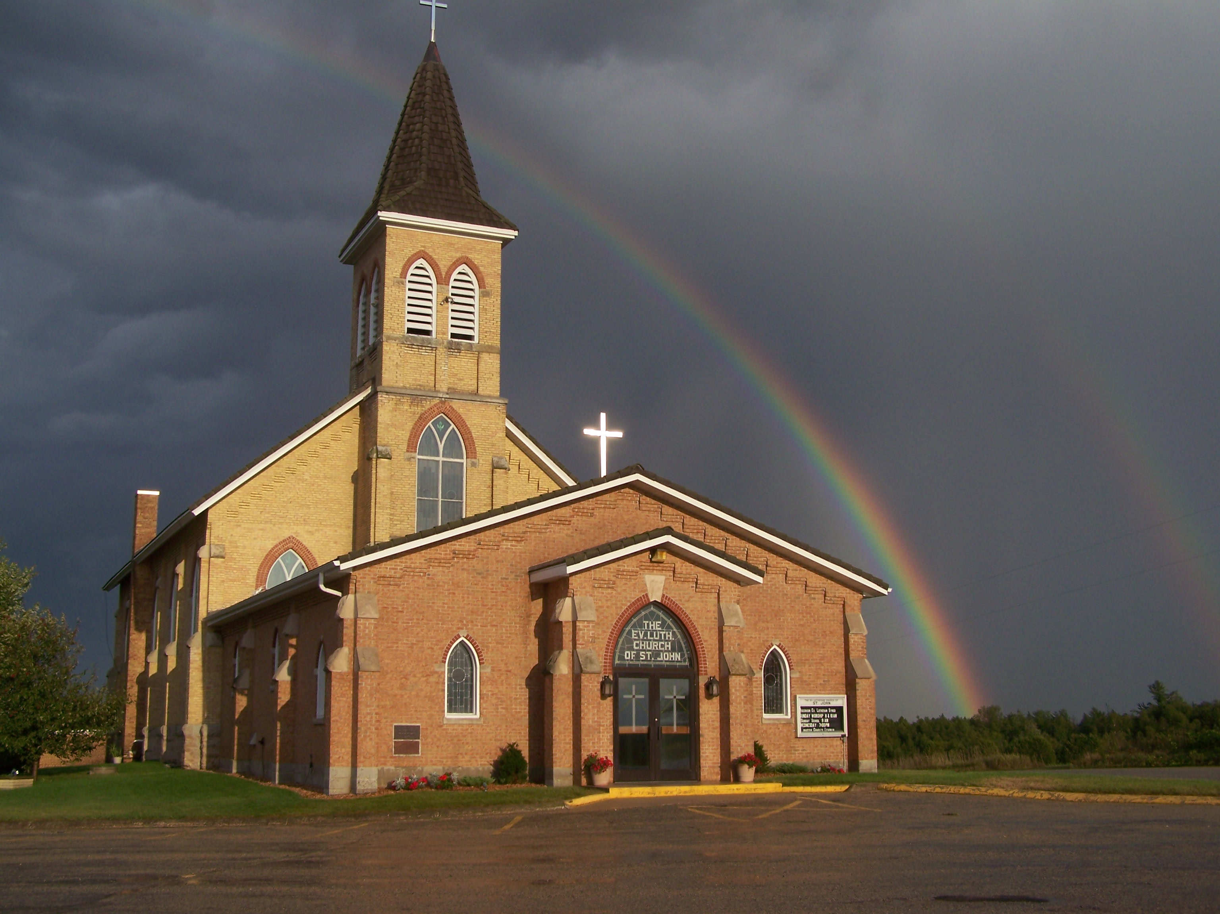
The Evangelical Lutheran Church of St. John
N1916 Church Road
Peshtigo, Wisconsin 54157-9673
Pastor Sargent 920-228-1061

03/11/2021

Dear members of St. John,



Numbers 21:4-9

Our sermon text for Sunday is Numbers 21:4-9. This is the story of bronze snake. “Look and live!”, Moses said. It would help them. It would save their life. Was it because it was a beautiful piece of art? No! It was not what Moses made that helped, it was the promise of God. They didn't have to do anything. They just "Looked and lived." And that is true for us also. As we look at this story we will see Jesus bring it full circle for us. When we look to the cross, we find life. We do nothing, it is all God. "Look and live!" That is our theme for Sunday!

Important Information:

Bible Study:


Our Bible Study is called Jesus’ Parables and the “I am Statements” Copies of the lessons are available from the ushers at church and can be found on the church webpage www.stjohnpeshtigo.org in the News Letter section. The second lesson will be posted on our YouTube page on Sunday March 14. Please join us for this 19 Minute study where we will visit with the Messiah. The lesson is titled; “The Light of the World ” (Matthew 5:14-16)

Sunday School:



Attention Parents!

We are in the Winter Lessons Schedule. The Lesson for Sunday March 7 is “Mary and Martha” found in Luke 10.

Click on https://online.nph.net/ss-remote
to view the videos.

Note to Parents: The Council has been asked to consider restarting in person Sunday School the Sunday after Easter. Parents will be contacted to see how many are willing to have their children attend. The online course will continue through the Spring Lessons even if we start up again. The Spring Lessons start on 21 March and are available today. Parents can find their children’s packet on the table in the front of church.

Worship: If you are not feeling well or have concerns about your own health, you do not need to attend. We will continue with the Livestreaming service at 8:30. If you would like to receive private communion at home please contact Pastor Sargent.
http://www.facebook.com/The-Evangelical-Lutheran-Church-of-St-John-Town-of-Grover-WELS-100389558275581/
https://www.youtube.com/channel/UCJ8tkCadzLHuxGWLhovgl8Q
Pastor Daniel Sargent

